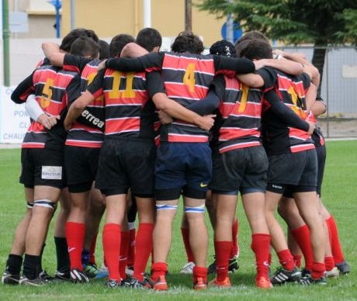

**POLICY RECOMENDATIONS REPORT**

**Ethics4Sports**

**an Erasmus+ project**

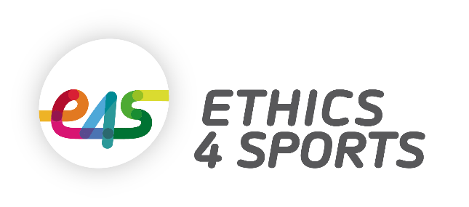 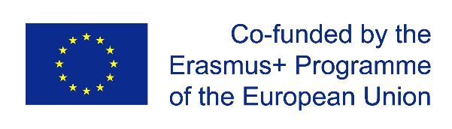

**ÍNDEX**

1. **Aims of the project**  4
2. **Some Important Background Factors** 4
   1. The role-model problem 5
   2. The different dimensions of ‘fairness’ 6
   3. Getting the fairness message across 7
3. **The E4S Project Stages** 8

STAGE 1: What is already done in different ways to promote ethics in sport? 8

STAGE 2: How can we best evaluate ethical and unethical behaviour in sport in Europe and capture its manifestations? 10

STAGE 3: What shall we evaluate? 16

STAGE 4: Results of the First Steps (Needs Analysis) 19

1. **Some Comments on These Early Results** 25
   1. Needs analysis: the ‘balance sheet 25
   2. Values and behaviour 25
   3. Beliefs and knowledge about ethics and codes 26
   4. Ethics codes 27
   5. Balance sheet about tools used for needs analysis 27
   6. New propositions for tools to simplify and complete the data collection 27
2. An E4S Ethics Code 28
3. Adaptation of tools for measuring sport values & pro-social/antisocial behaviour (Tool II) 28
4. Potential new tools for evaluation of the activities (Google forms) 29
5. Excel files to produce scores & graphs for different data from Google forms 30
6. The E4S APP: Collecting data in the field 31
7. **Using the E4S Tool Kit** 32
   1. Annual review of players’ values, pro-social and anti-social behaviour 32
   2. Evaluations at the end of each activity 33
   3. Using the E4S APP to allow us to collect and analyse data all year round 33
   4. Succeeding in involving everyone in this problem is a difficult issue 36
8. **Summary** 36
   1. Difficulties of data collection according to local institutional size and resources 37
   2. Generating cross-tabulations is important and interesting - but it requires more work 37
   3. The ‘Big Six’ 37
9. **Recommendations** 39

**ANNEX 1:** Synthesis of the Different E4S Partner Ethics Codes 45

**ANNEX 2:** Initial questionnaire 48

**ANNEX 3:** Simplified Questionnaire 56

**ANNEX 4:** Google Form (Tool 1, Part 1) 61

**ANNEX 5:** Google Form (Tool 1, Part 2) 63

**ANNEX 6:** Google Form (Tool 3) 65

**ANNEX 7:** Excel Files to Produce Scores & Graphs for Different Data from Google Forms 67

1. **AIMS OF THE PROJECT**

The main objective of the E4S project has been to identity and implement ways of promoting ethics and fair play in grassroots sports across Europe and to ensure their effective enforcement. The achievement of such ambitious goals requires the establishment of several sub-objectives. These have included:

* The development and/or improvement of new Codes of Ethics for sporting bodies and clubs to help spread ethical values in sport, following an inclusive and cross-cutting approach;
* The development of a set of verifiable indicators to facilitate the monitoring and evaluation of the enforcement of ethics codes at local levels;
* The effective monitoring and application of such codes, through the use of new technologies (for example, via the so-called ‘E4S Ethics App’);
* The testing, monitoring and evaluating of the enforcement of ethics codes, which will provide lessons learned for replicability around Europe;
* And finally, the setting-up of public-private networks of institutions and bodies aimed to co-operate in the promotion of ethics in sport in order to help identify new members who can be engaged in the future and enrich these partnerships.

Achieving even some of these goals will require rigorous action and strong commitment at all levels: pan-European organisations; national governments; governing bodies of sport; and local sports clubs. It is not simply a question of mobilizing secure and reliable methodologies, or developing and applying scientific tools, which in any case could create difficulties in the exchanges between international partners (academics, sportsmen, politicians) because of different expectations or different habits. It is to put knowledge and skills at the service of people around Europe who are directly in touch with the sporting field. This way of thinking necessarily leads us to proceeding in stages, which we detail below.

1. **SOME IMPORTANT BACKGROUND FACTORS**

In the *E4S Electronic Handbook* *on Fairness & Ethical Behaviour Best Practice in Sport in Europe* (2017) we wanted to raise some key background questions which were likely to shape or have some influence on our work. For example, questions about athletes in elite level or professional sport as potential role models for young people in Europe, at a moment when bending or breaking the rules, deception and cheating in some elite levels of sport seem to have become an institutionalised part of the competitive sporting ethic, something which is widely accepted by players, coaches and even by some partisan fans.

* 1. **The role-model problem**

In this sense, we wanted to try to avoid the mistakes of those so-called ‘sports evangelists’ who believe that involvement in sport *inevitably* contributes to the positive development of young people because sport’s assumed essential ‘goodness’ and ‘purity’ is somehow naturally passed on to those who watch or play it. We need to adopt a much critical approach than this in order to take a realistic view of the sports-ethics nexus. Indeed, when the stakes and rewards are so high in elite sport, and when the pressures on those involved are so extreme, it might be time to ask if we should routinely expect professional athletes to act as role models - as paragons of virtue and fairness - especially given our knowledge of these professional exigencies and also the heightened media focus today on the problem of cheating in some professional sports. We might also reasonably ask how parents and carers should deal with their own children in terms of asking who is, or who is not, an appropriate sporting role model today.

Research also indicates that *fans* of different elite sports may have very different approaches and different responses to ethical questions, including on respect for officials and strategic forms of cheating in their sport. Here, popular representative team sports may differ from more ritualistic, individual sports in important ways. It may also be the case that national sensibilities in Europe are likely to differ in relation to what is, and is not, regarded as acceptable or ‘fair’ in domestic professional sporting contexts.

Nevertheless, we also found some general common ground in this area. Indeed, it is not difficult to find inspiring examples, drawn from the highest levels of European and global sport, of public demonstrations of ‘fairness’ and sportsmanship which challenge over-conformity to win-at-all-costs mentalities, routine deception and manipulative self-interest. We include some notable examples in the *E4S* *Electronic Handbook.* Despite its many problems, elite level sport does still generate outstanding examples of what we might call the surviving ‘amateur ethos’ of fair play.

A public sporting panel event held by E4S in Leicester in April 2017 and involving sporting professionals from rugby union, basketball and cricket, largely confirmed the view that moral codes adhered to in professional sport are different from those operational at local levels. Given this fact, it is perhaps not surprising that many of the most notable examples of the promotion of ideals of fairness and inclusion involving people in elite sport actually occur *away* from the hyper-competitive playing arena.

Here, we explored in the *E4S* *Electronic Handbook* the involvement of sports stars in a wide range of inclusive activities and initiatives, many of which are laudably concerned with issues of social justice. Wider social projects, often using sport as a vehicle for public causes, range from the promotion of better health in European sports stadia, to support for development projects in poorer

European nations, anti-racism and pro-inclusion sporting activities, anti-domestic violence campaigns, and activities in European sports clubs based around anti-terrorism agendas. We should be clear that sport and its sporting stars do much important work *beyond the stadium and the arena* to offer marginalised people a chance of having better lives, to promote integration and greater tolerance across Europe, and to improve public health.

* 1. **The different dimensions of ‘fairness’**

According to the European Parliamentary Research Service’s *Overview of EU Sports Policy* (2015), the concept of the integrity of sport may be understood in two different ways. It can refer to the values that sport conveys and embodies, such as fair play, solidarity or team spirit – the main subject of this report. But it is also associated, secondly, with the integrity of sporting competitions, in the sense that these should be impervious to outside influences or external elements that could cast doubts about the way sporting results have been achieved. The issue of drug abuse is central here. The *Overview* further points out that the values and integrity of sports competitions are often deeply intertwined. For example, doping in sport breaches the principle of fair play, but it also clearly jeopardises the integrity of sporting competitions.

Doping has already had plenty of attention and we will not deal with that problem here. However, the *Enlarged Partial Agreement on Sport* (EPAS) from the Council of Europe in 2008 helpfully identified the two dimensions of fairness on which most theories of sports ethics can broadly agree:

• *An institutional dimension (an absence of discrimination based on criteria other than performance, uniform application of the rules, exclusion of arbitrary decisions)*

*• A personal dimension (in the form of a moral obligation to abide faithfully by the rules, in accordance with the principles of fair play)*

We have tried to address each of these dimensions in our deliberations here, but especially in the *E4S Electronic Handbook*. We build on this distinction, for example, in our discussion of academic approaches to the concept of fair play. However, these dimensions can also become deeply intertwined. The recent Serena Williams ‘episode’ at the 2018 US Tennis Finals is a case in point. Here unsporting behaviour was also underpinned, in many accounts, by enduring problems of racism and sexism in women’s tennis.

Research across Europe suggests that, despite recent advances, too many young females still feel there is no place for them in sport – that they are broadly excluded from it by its established conventions and its overly-macho ethos. Moreover, to manage their identities in the typically ‘male’ territory of sport, girls often have to find ways to combat assumptions about their sexuality and the challenge their involvement in sport poses to conventional, and often conservative, ideas about gender identities. Such issues may be made yet more complex by the ways in which the female body remains a highly-contested domain, especially perhaps in some faith communities.

* 1. **Getting the fairness message across**

The Council of Europe’s own *Code of Sports Ethics* (adopted by the Committee of Ministers on 24 September 1992 at the 480th meeting of the Ministers’ Deputies and revised at their 752nd meeting on 16 May 2001), has been argued to have fostered new campaigns in specific sports around fairness. A large number of sports organisations in Europe have set up ethics committees and groups and have drawn up codes of ethics since the Council’s own code was first published, though some work in this area also pre-dates the initiative of the Council of Europe: for example, FIFA has had a ‘fair play’ award since 1987 in recognition of ‘exemplary behaviour that promotes the spirit of fair play and compassion in association football around the world.’

As we have suggested, as professional team sport has become increasingly commodified, it is more difficult to find good practice that easily connects recreational sport with the wider sports business. Moreover, the Council of Europe’s Code is essentially a proclamation: it has not yet givenrise to the development of indicators on fairness in sport or to the close monitoring of ethical and unethical behaviour, for example in elite or recreational sport or in school settings. A new dialogue involving governments, sports bodies, and volunteers and administrators in local sport is urgently needed here, as well as new mechanisms to aid research for both data collection and analysis. Our own modest efforts may be part of this process.

All this means that we must commit to a version of sport and physical activities of a range and type that satisfies the needs of *all* young people in Europe, and which has a much stronger core emphasis on matters of fairness and ethics. As EPAS, itself, points out, physical and sports education should include learning how to make ethical choices. We should address accusations that sport is overly-competitive, even at this junior level, by doing more to challenge those who hold a zero-sum view of the nature of sport: the idea that winning is all and losing is somehow shameful.

Finally, we must accept, of course, that winning is clearly important and very rewarding in sport, but we can also argue strongly that honourable defeat after a tough contest, fairly played, can be more satisfying sometimes than an easy victory against a poorly matched opponent. Indeed, as we point out in the in the *E4S* *Electronic Handbook,* research consistently shows that winning is not top of most, younger children’s list of their early incentives for playing sport.

1. **THE E4S PROJECT STAGES**

We approached our E4S activities by dividing up our work into a number of logical stages:

**Stage 1**: Evaluate what has already been done or what exists at different levels, whether produced locally in sports clubs or more broadly by regional, national or even international institutions

**Stage 2**: Consider how we can best evaluate ethical and unethical behaviour in sport in Europe, and capture its manifestations

**Stage 3:** Present proposals to carry out these evaluations and thus identify needs within the sports structures investigated

**Stage 4:** Present some early results following these initial investigations

**STAGE 1: What is already done in different ways to promote ethics in sport?**

As indicated above, it is necessary, first of all, to try to identify what are the practices, the habits, the means already mobilized on the ground to promote and develop ethics in sport, in order to establish a bench-mark we can refer to. This can be undertaken in many ways, for example by adopting different, but complementary, lines of analysis. We also try to cover the general field and some of the definitional, practical and philosophical issues in play here, in the *E4S Electronic Handbook.*

1. ***The analysis may relate to practices at different levels in different sports and countries***

Some important actions/initiatives may be in play at local level (e.g. clubs, local authority, municipality, etc.). It is a matter of implementing concrete actions which can have a direct impact on the individuals concerned (most often the players or the fans), by appealing to the people directly in contact with the players (most often the coaches). Without going into detail here, among the initiatives identified we have, for example, shown that many sports clubs have adopted an ethical code or a charter of good conduct; others propose initiatives that work in a more indirect way, for example by offering cultural exchanges that enhance respect for others and improve social relations. Many examples of these are offered in the *E4S Electronic Handbook*.

Other initiatives or actions may work at a higher level (e.g. at sports federation or governmental levels, etc.). These initiatives may produce campaigns, confirm recommendations, or promote forms of action that can mobilize hundreds or thousands of people, in line with a specific socio-political orientation. For example, in France just before Euro 2016 the Minister of Urban Affairs, Youth and Sport, together with the French Football Federation (FFF) decided to reward ‘positive’ attitudes and positive behaviour among young soccer players (U12 and U15) by awarding a ‘blue card’ to two ‘fair-play’ players (one per team) in each match during the season. This institutional recognition thus has more scope to reach many more young people.

1. ***Analysing the initiatives identified and catalogued at both the local and national levels***

Thus, three ‘axes of reflection’ can be usefully identified to classify the precise nature of the intervention:

1. **Nature of the initiative: *‘Informative’ vs ‘Formative’:***  Informative actions aim to deliver certain messages to a target population through different media (e.g. posters encouraging sportsmen and women to respect opponents; commercials on TV to discourage discrimination, etc.) Formative actions are more direct actions, involving working with a target audience to directly transform their practice (e.g. by using training modules in line with ethics, in school or clubs)
2. **Status and character: *‘Incentive’ vs. ‘Obligatory’* status:** Incentiveactions refer to recommendations or advice that can be provided by a local club or more broadly by a municipality or a sports federation (for example, a sports club can encourage its players to implement pro-social behaviour and fair-play and on the contrary, strongly condemn any form of unethical behaviour).Obligatory actions refer, as their name indicates, to actions that clubs must necessarily implement, for example at the instruction of a federation or government (e.g. as part of federal or national programmes)
3. **Sanctions: *‘Repressive’* *vs.* *‘Preventive’* actions**: Repressive actions aim at imposing sanctions following non-compliance with instructions or the enacting of unethical behaviour (e.g. awarding a red card to a player who has just committed an unsporting or violent action). Preventive actions aim to act ‘upstream’, as it were, before any unethical behaviour has taken place. An example might be running a publicity campaign against foul play or discrimination that encourages people not to adopt this kind of ‘unsporting’ behaviour.

Thus, each action can be analysed with regard to these criteria and axes of reflection, as described in the graphic below:

|  |  |  |  |  |  |  |
| --- | --- | --- | --- | --- | --- | --- |
| Example of Action | Initiative form | Nature of the device | | | Main target | Stakeholders |
| Informative vs Formative | Repressive vs Preventive | Obligatory vs Incentive |
| Fan coaching | Local | Formative | Preventive | Incentive | Supporters | Clubs staff  Public organisations |

1. ***Ethics codes of sport clubs***

Notwithstanding the many examples of ethical/unethical behaviour that can be identified at the local, regional or national levels in sport and the fact that various actions can be implemented and categorized in this respect (see above), it remains the case that many (perhaps most) sports clubs – including all the partner clubs of this project - are already concerned with this issue and have developed an ethical code that is their own. The original Ethics Codes of the clubs involved in E4S were synthesised into one code (See Annex 1).

**STAGE 2: How can we best evaluate ethical and unethical behaviour in sport in Europe and capture its manifestations?**

The preliminary investigations we have conducted, aimed at identifying ethical/non-ethical practices and behaviours in sport and manifestations and actions that could be implemented locally or globally in order to promote and spread ethical values ​​in sport, made it possible to highlight certain convergences in key moments and principles to be adopted by this project. At the same time, however, there have inevitably been divergences: differences between different partners and between different countries in terms of ways of defining these behaviours and ethical values ​​and in the more concrete actions that might be proposed to promote ethical behaviour. Again, we try to cover some of these national and sport divergences in the *E4S Electronic Handbook.*

These arguments and the proposals they provoke might vary, for example, according to whether one is operating from an institutional (universities) or sports club point of view, at what level and type of sport one is discussing, if one is English, Italian, or German, or according to the number of people directly involved in the structures - very small sports clubs (such as AFC Barwell or Iserlohn) or much larger sporting structures (such as at SantCugatCreix or Anderlini).

We were well aware, from the outset, that both sporting and cultural differences and differences of scale and level of competition might all be very relevant here. As the *E4S Electronic Handbook* points out, certain types of cheating or fouling might be tolerated – even required or expected – in some sports, for example, but not others. Professional sportsmen and sportswomen often see what we might think of as unethical behaviour in local sport as simply ‘part of their job.’ Countries may operate different levels of censure and prohibition in relation to the same unethical behaviour because of cultural expectations. Gender differences were also likely to play a key role in defining acceptable and unacceptable forms of behaviour in sport, perhaps also mediated by national differences.

Therefore, the question is, necessarily, to know exactly how we might evaluate, as precisely as we can, these ethical values or these ethical or unethical behaviours in a fairly rigorous way, thus allowing us to establish some real and useful comparisons in the demonstrations and practices around sporting behaviour in different countries and at different levels of sport. Such comparisons might lead to some reasonably reliable conclusions and allow us, later, to produce some recommendations which have a broad applicability. Several forms of evidence can be collected to enable these investigations to proceed, including both qualitative data and quantitative data.

1. ***Collecting qualitative data about sporting ethics.***

These sorts of data allow us to identify, in the words and actions of our subjects, the feelings, the beliefs and the experiences they have of sporting ethics. Here we move from the abstract or the theoretical and broad-brush stokes to the everyday, the concrete and the specific. Such data may also emphasize inter-individual differences. Any individual is different from his/her neighbour, develops a personal identity, and apprehends the world differently. Access to this diverse and varied information allows us to have a more exhaustive and ‘rounded’ look at a given problem at the level of the individual, but it can also help us to illuminate repeat patterns of behaviour and it offers our subjects a voice and a stake in the outcomes of research and policy formation.

* 1. **Data collection** - Several types of tools or methods make it possible to obtain reliable qualitative data. We can conduct observations at sports clubs, or manage interviews or focus groups with target groups, who may testify to a particular experience or express their opinions about a specific subject. Alternatively, we can use ‘open’ questionnaires built with questions which allow respondents to write at length, *in their own words*, about their experiences and values. Content analysis or coding techniques can then be used to more finely analyse or categorise these data, if required.
  2. **Key indicators**: Concerning the issue of ethics in sport, the following questions/indicators can be explored in some depth to allow respondents to express their opinions and talk in some detail about their experiences and values:
* What do different actors understand by ‘ethical’ and ‘unethical’ behaviour in sport?
* How important are these matters of ethics to them?
* What do different actors know about what is happening in their club in relation to the promotion and evaluation of ethics?
* What do those involved in local sport think about ethics practiced in professional sport?
* Do they follow role models in elite sport? Who is concerned by ethics?
* Do they know anything about the contents of existing ethics codes at their clubs?
* How do they balance winning with playing in an ethical way?

Typically, collecting qualitative data – which is often the best option for research with very small numbers at smaller sporting clubs – involves observing at events, sampling and interviewing club members, coaches and parents - and also young players – to explore the importance of ethics and local campaigns in sport at club level. This can help explore the starting points in debates about ‘fairness’ and also the extent to which clubs have managed to get the ‘right’ message out about promoting ethical behaviour in sport:

* These data can illustrate the general ‘condition’ of the club regarding ethical behaviour
* They can help show where, in its structures and memberships, more support work is needed
* They can provide useful material for discussions about ethical behaviour & parental, coach and athlete concerns
* They can also be used – on websites and in club literature - to develop the ‘brand’ image of the club.
* Interviewees can be encouraged to take ‘ownership’ of ethical questions & be more reflexive in real life

This approach can operate at a relatively informal level – for example, a coach having a conversation, shaped around key themes, with parents, players or administrators and writing up notes on the discussion. Or it can be more formal; for example, a trained researcher interviewing individuals or running focus groups aimed at analysing approaches to exploring knowledge about, and attitudes towards, ethical behaviour:

* Collecting these data can indicate the complexities of ethical concerns in the words of our subjects
* Collecting qualitative data over time can also help establish baselines, monitor change and identify key points of concern, resistance & support
* The main emphases here should be on assessing understanding, highlighting concerns & potential barriers, and seeking out pathways for development
* It is also important, of course, to follow appropriate ethical guidelines on collecting and using interview material

These approaches lack the representativeness and generalisability of large-scale survey, but in the ‘real’ world of open dialogue in face-to-face exchanges – where responses are freely given in the words of the subject and not limited to ticking a box on a scale – the true complexities and contradictions involved in views about ethics in sport can often be revealed. In the course of this project the E4S group produced some recommended questions on sporting ethics, for example, for use with parents at junior sports clubs. We include a selection of 10 useful questions below:

**SUGGESTED QUESTIONS FOR QUALITATIVE ANALYSIS**

1. What do you like/dislike about this club? Why did you choose it for your son/daughter?

2. Does this club have a good approach to sporting values do you think? Why?

3. Why do you want your child to play sport? Fun? Learn things? Interact with others?

4. What do you hope your child will learn from playing at this club?

5. Is playing sport in a fair way important to you? Why?

6. Do you think your child is influenced at all by how professionals play sport?

7. How should we balance playing fairly & winning for children?

8. Does this club have a code of ethics? Do you ever read it?

9. Do you ever talk to coaches at the club or other parents about fairness?

10. Do you talk to your children about sport & fairness? How important is it to you?

We also include, below, just a few short examples from interview data we collected at our volleyball club in Anderlini in Italy, a local roller hockey club in Iserlohn in Germany, and at soccer clubs in Sant Cugat del Vallès, in Spain, and at AFC Barwell in the UK:

**SAMPLES OF E4S QUALITATIVE MATERIAL ON FAIR PLAY**

*‘AFC Barwell has some great values. It’s part of the Barwell DNA. It’s in the book that they give you. It’s in the club’s ethics: we are a fair, equal club. I think fun is one of our core values. Teamwork – I think we get good values from the core. It is a good set of people here.***(Soccer coach, AFC Barwell, UK)**

*‘The players of our team made fun of the others when they were winning by 4-0, saying that they were ‘penguins.’ Then the parents of the opposing team began to produce insults. This is in a game of children of 7 years of age! Half-way through, we talked with the children so that it does not happen again.’***(Soccer coach, Sant Cugat)**

*‘Scuola di Pallavolo Anderlini goes beyond the technical aspects of sport. Here I can express the values in which I believe, which are written in the Charter of Ethics. I can learn new things thanks to training courses. Here we believe in young people.’*

**(Volleyball coach, Anderlini)**

*‘I have caught myself shouting to my son during the match. It is hard work for me not to do it.’***(Parent, Iserlohn, roller hockey club)**

*‘Penalty decision - great discussion between both clubs on the field as even the coaches felt unfairly treated.’* **(Parent, Iserlohn, roller hockey club)**

*‘I think the club likes to play fairly. This club would never ever cheat, but other people take advantage of it. Other clubs turn a blind eye. Games are never fair: everyone wants to see their side win. Parents should be there to support their children, not have a go at the ref. But that happens. We get moaned at by our coaches if things go wrong: ‘Please keep it down.’ I think this club is humble, maybe too humble. You need to fight for what is right, not accept that blind eye.’* **(Parent, AFC Barwell soccer club)**

Interview data such as this can be used in a ‘stand-alone’ capacity for illustration and to map resistance and change, but it can also usefully complement and add a ‘human’ dimension to numerical survey data. In short, we would advise using a range of methodologies to collect material on fair play issues, depending upon available resources, the subjects under review and the precise matters we are addressing. The most important thing here is selecting the most appropriate ways of collecting data and keeping the ethics question in focus, on the agenda, for sports club members, coaches, parents and administrators.

1. ***Collecting quantitative data about sports ethics.***

Quantitative data can also be obtained and used to positive effect. These are generally intended to produce a broader, more representative, view that can lead to generalizations about major trends in values and behaviour shared by a large number of people. Such approaches are more interested in observed regularities in reported behaviour and attitudes, thus allowing for the production of recommendations based on responses from reasonably large, and more representative, samples of respondents:

**Data collection** – Several techniques and tools are also available here, such as closed multiple choice questionnaires, the use of Likert-type scales, self-report studies, on-line surveys, and observations using precise measuring tools such as observation grids.

* 1. **Key indicators** – Thus, some questionnaire or survey responses may allow one to evaluate:
* The incidence of unethical behaviour, over time, in different sport and club settings
* How seriously different actors take the matter of ethics in sport
* What sport values and attitudes are developed by specific target group (players, coaches, parents)?
* What level of ethical or non-ethical behaviour do the players and others claim to experience?
* What level of ethical or non-ethical behaviour do players perceive in their coaches?
  1. **Personal and contextual demographic data**

These should also be considered and, as we pointed out earlier, they are likely to be of some importance here. Collecting these data allows one to make useful cross-comparisons assessing responses of specific groups, which can result in a finer analysis of the quantitative data. Thus, the contextual data listed below have been the main focus of our attention in this project:

**USEFUL CONTEXTUAL DATA**

Gender

Age

Level of sport (recreational, amateur, professional)

Social background

National identity

Type of sport

Level of club competition

**STAGE 3: What shall we evaluate?**

Following these reflections, we made the following proposals for evaluations and needs analysis. These were adopted by the different partners of the project:

* + 1. ***Sport values***

Values are general principles that guide behaviour across different social situations. So, they should underpin decision-making in sport, specifically those pertaining to achievement and morality. Evaluating sports-related values among players seems unavoidable when one is interested in sporting ethics. Many scientific studies have established a correlation between values and attitudes and behaviour (e.g. Lee, Whitehead, Ntoumanis, & Hatzigeorgiadis, 2008[1]). The questionnaire constructed by E4S seemed particularly relevant because it was shaped around this connection and specially designed for use with younger athletes. This questionnaire identifies three different sport values: ‘Moral values’; ‘Skills values’; and ‘Status values’ (see Appendix 5).

Each of these dimensions of value was composed of four specific items, and participants in the study had to complete the questionnaire by circling the number which best describes what they think about statements offered to them (from 1 = *Not important for me at all* to 5 = *Extremely important for me*).

* + 1. **Moral values**, for example, are evaluated through responses to Items such as: “*When I play my sport, what is most important for me is to try to play fairly.*”
    2. **Competence or skills values** are evaluated through Items such as: “*When I play my sport, what is most important for me is to try to use my skills well.”*
    3. **Status values** are evaluated through Items such as: “*When I play my sport, what is most important for me is to try to show that I’m better than others.*”
    4. ***Pro-social and antisocial behaviour***

Responses to questions about pro-social and anti-social behaviour by athletes were also examined. This part of the questionnaire was based on Kavussanu and Boardley’s work (2009[2]) which distinguishes two different targets for pro-social and antisocial behaviour: teammates and opponents. But another target seems very relevant to consider here: the referees and officials. Each week-end examples of criticism and abuse addressed by athletes to referees and officials are relayed by the media, especially in certain contact team sports (particularly football). The project partners, therefore, decided to include responses to match officials in the proposed questionnaire.

The questionnaire was composed of three different subcategories, related to pro-social and antisocial behaviour. Specific items were composed of each sub-category (see Annex 2).Participants had to complete the questionnaire (16 items) by circling the number which best described how they think they behaved during the last season (from 1 = *never, t*o 5 = *very often*).

* + 1. **Antisocial behaviour towards teammates** is, for example, evaluated through Items such as: “*During the last season, how often did you* *shout abuse at a teammate?”*
    2. **Antisocial behaviour towards opponents** is evaluated through Items such as: “*During the last season, how often did you* *openly criticize an opponent?”*
    3. **Antisocial behaviour towards referees** is evaluated through Items such as: “*During the last season, how often did you**argue with the referee?*”
    4. **Pro-social behaviour towards teammates** is evaluated through Items such as: “*During last season, how often did you* *say something to encourage a struggling teammate?”*
    5. **Pro-social behaviour towards opponents** is evaluated through Items such as: “*During the last season, how often did you congratulate an opponent for good play?”*
    6. **Pro-social behaviour towards referees** is evaluated through Items such as: “*During the last season, how often did you* c*ongratulate the referee for a good match?”*
    7. ***Players’ perceptions of behaviour of coaches and opponents***

If the self-reported behaviour of players is important to evaluate in order to verify if actions promoting ethical behaviour in sport are effective or not, it is also important to identify which factors are likely to influence these behaviours, in order to target more specific and relevant forms of action. The role of the coaches often appears to be important, because they constitute models, in particular for the youngest players (cf. *E4S Electronic Handbook*). Similarly, players often justify their behaviour in terms of what they themselves suffer. The project partners therefore decided to collect data on what the players thought about the behaviour of their coach and their opponents. The same questionnaire as before was proposed, modifying the title of the questions.

The participants had to complete the questionnaires (16 Items each, Annex 2) by circling the number which best described how they think their coach behaved during the last season (from 1 = *never* to 5 = *very often*) or how they think their opponents behaved during the last season (from 1 = *never,* to 5 = *very often*):

1. **Anti-social behaviour towards teammates** is evaluated through Items such as: “*During the last season, how often did your coach*/*your opponents* *shout abuse at a teammate?”*
2. **Anti-social behaviour towards opponents** is evaluated through Items such as: “*During the last season, how often did your coach*/*your opponents, openly criticize an opponent?”*
3. **Anti-social behaviour towards referees** is evaluated through Items such as: “*During the last season, how often did your coach*/*your opponents argue with the referee?*”
4. **Pro-social behaviour towards teammates** is evaluated through Items such as: “*During the last season, how often did your coach*/*your opponents say something to encourage a struggling teammate?”*
5. **Pro-social behaviour towards opponents** is evaluated through Items such as: “*During the last season, how often did your coach*/*your opponents, congratulate an opponent for good play?”*
   * 1. ***Athletes’ beliefs and knowledge about ethics code at their clubs***

Our qualitative and personal and contextual data can be used to help refine the quantitative data obtained through use of the various questionnaires and can help identify what different types of individual think and know about sports ethics in general. We can also find out more about the people who athletes consider to be particularly concerned by this issue and their knowledge about actions carried out by their club in this respect. They also make it possible to check whether the actions already implemented by clubs are relevant or not in addressing unethical behaviour. A set of questions specific to these issues were therefore proposed for the project participants (See end of Annex 2).

For example:

“*Do you know if your club has a written-down set of rules on how you should behave?”*

*“If yes, how did you hear about this code?”*

* + 1. ***Comparison of ethics codes and identification of common categories***

Finally, one further goal of the project was to compare policies in different countries. These comparisons allow us to identify national differences and some common and different processes, as well as to confront different ideas and actions related to ethics in sport across Europe. Each sports club partner of the project already had a specific ethics code. There were all analysed, with the aim of identifying a potential common structure we could spread across all our European partners.

**STAGE 4: Results of the First Steps (Needs Analysis)**

Some early results obtained through use of the different tools and methodologies presented and explained previously are presented below. They are not exhaustive, of course, but they reflect the diversity and complementarity of the data obtained in this first phase, which has subsequently made it possible to establish certain observations, to identify certain limits or constraints, and subsequently to evolve the tools and procedures used, while opening us to reflections on possible new directions and recommendations. In total, over 1880 young players in different sport from Spain, Italy, England and Germany participated in contributing to this first dataset.

* + - 1. ***Athletes’ beliefs and knowledge about ethics code at their own club***

Some 75% of our respondents claimed to know that a code of ethics existed at their club. The main source of this knowledge for them was the club coach (36%) and other club staff (27%).

The club website (10%) and posters (7%) were less prominent here. Identified targets for the club ethics code are various, indicating the complex interpretation of ‘fairness’ (see Figure 1)

*Figure 1 : Preferred elements for club ethics codes*

* + - 1. ***Players’ anti-social and pro-social behaviour and their relation to sport values***

*Figure 2: Pro-social and antisocial behaviour self-reported by players: by target*

As indicated in Figure 2, pro-social behaviour as self-reported by players is high and there is no significant effect in terms of target (referee, players, opponents, etc.). On the other hand, reported anti-social behaviour, although it seems to be quite weak (Figure 2), is much more unevenly distributed according to the target. The referee is clearly the main target for this type of behaviour. It is also interesting to note that the anti-social behaviour declared by players is significantly related to status values: that is, the higher the status values of players, the higher the reported anti-social behaviour.

* + - 1. ***Coaches’ pro-social and anti-social behaviour as perceived by players and its relation to players’ anti-social and pro-social behaviour.***

As indicated in Figure 2, pro-social behaviour of the coach, as perceived by players, is quite high too and there is no significant relationship with different targets. On the other hand, anti-social behaviour by coaches, as perceived by players, seems to be quite weak. For the players, it is the *referee* who is perceived as being the main target for anti-social behaviour by the coach. It is also interesting to note that self-reported pro-social and anti-social behaviour is positively correlated to the perceived behaviour of the coach. That is, the more pro-social the behaviour of the coach, the better the behaviour of the players.

* + - 1. ***Effect of personal and contextual data***

Some of the most interesting results can be observed if we use some of the personal and contextual data we have collected as part of this preliminary analysis. *Firstly*, the ***level at which sport is played*** seems to be quite a strong predictor in terms of values and ethical behaviour. As indicated in Figure 3, the higher the level at which sport is played, the higher is players’ self-reported anti-social behaviour and coaches’ anti-social behaviour, as perceived by players. No meaningful effect of sport level was observed for pro-social behaviour. This indicates, of course, that the more serious sporting competition becomes, the more likely that anti-social behaviour is likely to intrude among both players and coaches – and perhaps it becomes more accepted or even expected.

*Figure 3:* *Pro-social and anti-social behaviour self-reported by players and perceived among coaches according to the sport level*

*Secondly*, ***gender***appears to be a relevant characteristic too (based mainly on the data obtained for female volleyball players). Indeed, status values and anti-social behaviour self-reported by players are both higher for males than for females (Figure 4). And, as we saw earlier, status values and anti-social behaviour are significantly correlated.

*Figure 4: Pro-social and anti-social behaviour as self-reported by players and sport values according to gender*

*Thirdly*, ***type of sport*** is an interesting variable, too. We cover this issue in detail in the *E4S Handbook* and it is revealed particularly in data from a range of sports gathered from SantCugatCreix. As indicated in Figure 5, pro-social behaviour as self-reported by players is higher for rugby than it is for football, volleyball or basketball and anti-social behaviour perceived among coaches is lower for rugby coaches than it is for the other sports.

*Figure 5*: *Pro-social and anti-social behaviour self-reported by players and perceived among coaches: by type of sport*

*Finally,* ***country*** may be an important variable in predicting attitudes toward sporting behaviour. Comparing only volleyball data from both Italy and Spain (Figure 6), status values expressed by Italian players are higher than those of Spanish players. Moreover, anti-social behaviour self-reported by players and those perceived for the coaches are higher for Italian participants, while pro-social behaviour self-reported by players and those perceived for the coach are lower for Italian players.

*Figure 6:* *Pro-social and anti-social behaviour self-reported by players and perceived among coaches by Spain and Italy*

1. **SOME COMMENTS ON THESE EARLY RESULTS** 
   1. **Needs analysis: the ‘balance sheet**

The early results obtained during the needs analysis phase of the E4S project make it possible to draw several preliminary conclusions and to formulate some new lines of inquiry which make it possible to develop the project moving forward. Let us look at these now.

* 1. **Values and behaviour**

The evaluation of the sports values data provided by the participants, as well as the pro-social and anti-social behaviour data self-reported by the players or perceived among their coaches, seems to hold some considerable significance**.** Indeed, it is quite clear that attitudes and experiences of anti-social behaviour among survey participants are related to status values. The more importance an athlete attaches to his/her status, the more he/she will tend to do whatever it takes on the field or in the arena to achieve domination/success goals. Identifying higher values relating to the status of athletes provides an interesting indicator of where – and among whom – anti-social behaviour is likely to occur and where remedies are, arguably, most required.

On the other hand, the coach's role is also of central importance. Indeed, a strong correlation exists between the behaviour self-reported by players and those perceived as being common among coaches. The latter should constitute important role models and instructors, especially among young people in sport, whether for transmitting socially valuable characteristics (pro-social behaviour) or for outlawing much less acceptable behaviour (anti-social behaviour). It is essential that coaches be made aware of their impact and realise their potential as good role models, especially for younger athletes.

A detailed analysis of self-reported behaviour by players and perceptions of coaches highlights the fact that referees and officials are the preferred target for anti-social behaviour and that they are the least likely subject of pro-social behaviour. Particular attention should be paid to this situation and it is appropriate that the tools/actions/strategies implemented to promote improved ethics in sport among young people put some of the accent on this particular problematic.

Finally, it is clear that many demographic and contextual variables play a significant role in promoting specific values and behaviour in local sport: gender differences and the level at which sport is played seem to be the most relevant in this instance. It is therefore necessary to be particularly vigilant in this regard; higher level male sport seems especially problematic in this respect and perhaps we should focus more of our attention and resources on this specific dimension of non-professional sport in Europe.

* 1. **Beliefs and knowledge about ethics and codes**

The results obtained from the survey may also serve to guide our actions and our proposals about promoting positive ethics among young people in sports clubs. Indeed, the following early observations can be made:

* Only about two-thirds (65%) of all participants were aware of the existence of an ethical code at their own club, even though *all* our project partners had developed and promoted their codes and were already implementing actions in relation to such codes. Interviews suggested few young people ever consult ethical codes even if they know of their existence. The question therefore arises about promoting greater relevance and visibility of these codes and assessing their mode of presentation and impact on target populations.
* The various mechanisms and media used to promote ethical codes in local sport may be questionable. It seems that not every practice has the same reach and impact. Thus, the direct approaches of those involved in sports structures (coaches, leaders, etc.) seem more relevant and impactful than visual information (in posters and on websites). Indeed, coaches and staff were quoted by more than 40% of respondents as a key source of information, while posters and the club website are cited in only 10% of cases.
* Finally, it seems that a wider communication is needed around this issue. In fact, most of the participants in the study consider that the people concerned most with communicating messages about sporting ethics are essentially players and managers, who are quoted at more than 40% each. In contrast, coaches receive only 25% of responses and parents less than 15%, which seems to reflect that their role is largely minimized in this issue. However, the survey results concerning anti-social and pro-social behaviours have clearly highlighted the role of model coaches more specifically. It would therefore be important to highlight the role of the mediator exercised by coaches and parents, who are also vectors of values and good attitudes.
  1. **Ethics codes**

The in-depth analysis of the different ethical codes held by partner organisations has highlighted many common points in the structuring of these codes and their proposed content. This kind of analysis thus makes it possible to envisage that a common ethical code can be proposed and applied in a trans-cultural way and across most sports, at least with regard to general principles.

Similarly, the survey highlighted central elements in the reflections of our subjects, each quoted by more than 40% of respondents - respect of the opponents, of the referees, of the infrastructures, to play fairly and to enjoy sport. These indicators will be able to feed reflections around the construction of a common ethical code.

* 1. **Balance sheet about tools used for needs analysis**

The tools used for this form of needs analysis make it possible to highlight a set of core concerns, or directions, that should be considered, at least with a little caution, in terms of drawing up, too hastily, possible conclusions and some recommendations. But this first step has also allowed us to take a movement back to reconsider and redevelop some of the tools and procedures adopted. A reflexive analysis is necessary when one seeks to evolve tools in an on-going project. This analysis has led to the evolution of tools created and used, essentially by simplifying of them, so that they are better adapted for use with the public (especially younger players). But this analysis has also highlighted the need to propose complementary tools - qualitative approaches - in order to allow the evaluation of the activities implemented by clubs to promote ethics in sport.

* 1. **New propositions for tools to simplify and complete the data collection**

In order to progress and improve the relevance of the tools used and to better evaluate the actions implemented to promote ethical behaviour in sports clubs, several new propositions were put forward:

1. ***An E4S Ethics Code***

The analysis of different existing ethics codes revealed many common points in the content and structure of these codes. Thus, four central value strands have emerged, concerning athletes, staff and parents. These are:

**FOUR CENTRAL VALUE STRANDS**

* + Respect
  + Team spirit and Solidarity
  + Responsibility
  + State of mind

Each of these categories could then be broken down into sub-categories, with regard to the targets concerned, namely: athletes; coaches/administrative staff; and parents. For example, regarding the category ‘respect’, it could be considered under four subcategories for athletes:

* Respect for the rules of the institution (the club, the referees, choices of coaches, etc.)
* Respect for the rules/laws of the game (do not cheat, do not hurt, do not insult, etc.)
* Respect the social rules of the group (no discrimination, bullying, judgment, etc.)
* Respect the gear and equipment provided (no damaging club property)

These sub-categories can also be adjusted and identified for use with club staff and for parents. The suggested common E4S Ethics Code is presented in Annex 6. The realization of this common code has made it possible to link the values expected and to promote sports ethics among young people in their behaviour/actions identified on the ground, thanks to the E4S APP (see section below on the APP)

1. ***Adaptation of tools for measuring sport values & pro-social/antisocial behaviour (Tool II)***

The attempt to implement tools to evaluate the sports values developed by athletes, and the pro-social and anti-social behaviour self-reported by competitors or perceived among their coaches, led to two specific problems:

1. Firstly, the initial questionnaires were discovered to be too lengthy to complete by athletes; they were simply too complex and had too many questions. This risked creating resistance among the respondents and a high rate of non-response or incomplete answers. They had been designed with scientific validity in mind, but such tools are useless if they have no practical applicability, no matter their scientific merit. As the participants were mostly quite young and unaccustomed to completing questionnaires of this type, it was necessary to simplify the process.

The choice was therefore made by the project partners to produce shorter, less complex, tools by reducing the number of items for each category investigated (for example, the questionnaire on values, while retaining the three dimensions, was reduced from 12 items at just six, and the questionnaire on perceptions of pro-social and anti-social behaviour went from an unwieldly 18 items to six, too. Moreover, the questionnaire originally planned to try to evaluate the pro-social and anti-social behaviour perceived by players in relation to their opponents was discarded completely because it was considered less relevant in view of the results obtained during the needs analysis. The questionnaires concerning the players and the responses of their coaches were maintained. The simplified questionnaires are presented in Annex 3.

1. The second problem encountered during Phase 1 was the sampling and completion method adopted. Indeed, the different questionnaires in their longer versions were proposed to be used online, by using a specific internet link. This methodology was relevant from the point of view of the processing of the large amount of data which might have been collected (automated processing of large datasets), but this would have forced often quite young people to use a parental computer or a computer available at their sports clubs, which created logistical difficulties in the implementation at the partner clubs because they did not always have sufficient personnel and logistical means to organize specific feedback sessions. The decision has therefore taken to proceed with much shorter questionnaires in the shape of Google forms, which are much more widely used and more easily mastered by participants (perhaps especially younger people). Players, parents or club supervisors were also offered a paper version for those respondents who do not have access to, or feel uncomfortable using, a computer.
2. ***Potential new tools for evaluation of the activities (Google forms)***

The needs analysis also highlighted the need to assess the relevance of the actions implemented by clubs and their real impact for the promotion of ethical behaviour in sport among young people. Many activities/actions were produced by the partner clubs, but their impact does not necessarily match the commitment and the efforts and costs necessary for their implementation. Several tools have been created to help partner clubs evaluate their activities in a fairly simple and inexpensive way. As we indicated above, these tools were also offered as Google forms, which can be completed online or in hard copy.

* 1. **Tool I - Part I: descriptive data about activities (Annex 4)**

The first tool aims to describe each of the activities implemented to promote ethical sporting behaviour. Simple information is collected (club or organization concerned; theme of the proposed activity; type of people in charge of producing the activity; target audience; number of participants, etc.). These data make it possible to quickly *record* the activities carried out over a year and to compare their evolution and development from one year to the next.

* 1. **Tool I - Part II: evaluation of activities by audience / satisfaction (Annex 5)**

Then, it is necessary to evaluate the *impact* of these activities on participants. A very simple and very short satisfaction questionnaire was thus developed to verify the relevance and usefulness of the proposed action and to make it possible to change the content or general approach if necessary.

* 1. **Tool III: Match records (Annex 6)**

A third tool was tested, aimed at collecting data relating to what was happening directly on the pitch and in the arena, but from the point of view of officials and observers and no longer simply players. For example, we experimented with a plan to count the yellow or red cards during a match, to note the number of incidents that interrupted the game, and to evaluate the sporting behaviour of the team on a simple 10-point scale (from 1 = not fair at all, to 10 = extremely fair). This evaluation was to be made by different actors: the referee, the coach, the spectators and the opposing team.

Even though these data were very simple, these possible evaluations posed some severe problems, for example in terms of how few ‘cards’ were awarded in different sports and at junior levels and in relation to the implementation of some of these measures (Who asks the referee? Who goes to the meeting of the spectators to collect data on their opinions?). These proposed evaluations are also quite restrictive and are only really concerned with certain types of contact team sports and not with other types of sporting practice. They were therefore abandoned quite quickly, despite the possible relevance of the data that might have been collected.

1. ***Excel files to produce scores & graphs for different data from Google forms (Annex 7)***

The first stage of needs analysis also highlighted the difficulty that some sports clubs – especially smaller ones - were likely to have in analysing their own collected data. Indeed, not all sports organizations have the human resources available to perform this not insubstantial task. Larger, integrated sporting structures can call on additional experts, such as sports psychologists or academics, who can collaborate to produce reports and analyses, but smaller sports clubs, generally speaking, work with a relatively small number of people, who are often local volunteers who do not have the time or the skills to perform this task, which can be quite complex and consuming.

An easy-to-use excel file was therefore developed in order to calculate the scores obtained by means of the different questionnaires (sports values, pro-social and anti-social behaviour self-reported by the players or perceived in terms of their coaches, satisfaction indexes, etc.), and which produced automatically updated charts. Each step is carefully explained to help subjects complete this process. This tool helps the data analysis and their exploitation is interesting because the graphical data are often much more explicit and comprehensible to a visually-attuned public (a report presented in a club general meeting, for example, or a report on action taken with a federation or municipality that is mobilized in relation to this issue, etc.). All this allows our partners to quickly *visualize* the impact of an action or to respond to public concern about specific issues concerning ethical issues at local clubs.

This tool was only deployed very late in the project and it could not really be implemented effectively by the different sports partners. Nevertheless, this is a potentially very interesting development that should be tested in the future.

1. ***The E4S APP: Collecting data in the field***

Finally, and crucially, a simple APP has been developed by the project with the aim of collecting information in real time about behaviour or situations actually encountered on the field or in the arena, during training or games. The APP was conceived in relation to the ethics codes of clubs and the common code which E4S has developed, about ethical or non-ethical behaviour observed in sporting practice. Everyone involved - players, coaches, staff, parents, spectators - is free to connect via the E4S APP and to report their observations and opinions about examples of both ethical and unethical behaviour and events.

The APP allows for the collection of some basic information about the people who are reporting on incidents or practices, either positive or negative. These data are collected to allow us to analyse the APP reports a little more qualitatively, beyond the simple number and type of reports. They typically include: country of origin, type of sport or club, the status of the persons who logs into the APP (athlete / parent / staff/ observer, etc.)

As one moves through the screens of the APP, the user is then required to provide a little more *contextual* and detailed information on what has been observed in the field:

* The type of situation or event (negative/positive)
* Sex and age of the persons concerned in the identified event
* Where the event or practice took place
* The status of people concerned in the event/practice (athletes, parents, staff, spectators)
* Sub-category of the E4S ethics code which best covers the reported incident
* A brief description of what the reporter actually saw

The aim here, of course, is to strike a balance between the need to collect some detailed material on the incident being reported and making the process of reporting simple enough so as not to deter people from engaging with the APP.

1. **USING THE E4S TOOL KIT**

Several tools have been developed throughout the time of this project in order to reflect on how sports clubs in Europe might promote, record data and develop programmes in relation to sports ethics. We have been concerned, especially, to try to verify what activities and actions are relevant here and what sorts of strategies really impact on the target audiences concerned.

In a more general sense, the realization of this project has essentially turned towards the objective of creating useful tools and testing their relevance in real life situations. It should now be possible to implement them over the longer term in order to ascertain whether analyses, observations, trends identified and the conclusions produced at the end of this short period have a longer-term applicability.

In fact, of course, promoting and sustaining ethical behaviour in sport means changing attitudes, values and habits that are sometimes deeply rooted in specific cultures, and these sorts of developments in approach can only realistically be conceived with years of commitment to policy and attitudinal change. It is useful to implement devices to record and encourage change, but wider cultural and societal shifts will be required in the long run.

* 1. **Annual review of players’ values, pro-social and anti-social behaviour**

With regard to the *values* developed by the practitioners, the pro-social and anti-social behaviour they implement, or those which coaches are planning, an annual review of players’ attitudes and perceptions might be envisaged. For example, at the beginning of the season, questionnaires could be completed by players/athletes with regard to their perceptions and experiences of the previous season. This would make it possible to check whether there is a change from one year to the next in this respect. It might also help us assess whether programme introduced by clubs have had an impact in changing behaviour or values in the shorter term.

* 1. **Evaluations at the end of each activity**

In the same way, the impact of each proposed activity or situation organised to promote more ethical behaviour or more reflection on the core issues could be assessed each time they are implemented. Comparing the data collected for the same activity on a recurring basis over time would not only make it possible to verify its effect over the long term, it would also test its relevance in the shorter term, in order that clubs and researchers could possibly modify its content, objectives or the way it is implemented.

* 1. **Using the E4S APP to allow us to collect and analyse data all year round**

The routine use of the E4S APP at club or network levels whenever a situation is identified also provides relevant information and checks, for example throughout the year but also for the production of a six-monthly and annual report, in order to identify possible ‘spikes’ in reported unethical activity and whether or not new developments can be observed, and in what area or country and in which sports. Extended use of the APP has the potential to considerably increase our knowledge, deal with public concern, and enhance our capacity to analyse and resolve instances of unethical behaviour in sport, was well as coming up with new ideas about how to produce new strategies and policies at club, regional and national levels.

For example, some data were obtained by using the pilot APP just before the end of the project, which we can briefly summarise some here:

* More than 1000 events/incidents were registered with the APP, most of them in team sports
* Some 96.3% of these were reported by club staff and 73% of the persons concerned in the situations reported were athletes
* Some 60.6 % of the situations reported were conflict situations, while 39.4% were positive. But this distribution is different according to different sports. For example, in rugby, the
* distribution between positive and conflict situations is balanced whereas conflict situations are registered more than positive situations in the other team sports (See Figure 7)
* Some 48.9% of the persons concerned in the identified event were male, 35% were female and the two sexes were jointly concerned in 16% of the reported events
* The main age categories were 12-13 years old (19.4%) and 14-15 years old (17.8%)
* A large majority of the situations recorded took place on the field during home games (48.9%) or during training (39.1%) (Figure 8)

*Figure 7: Percentage of conflict and positive situations registered on APP according to type of team sport*

*Figure 8: Conflict and positive situations registered on APP according to place*

As regards the use of a common ethics code, some interesting data from SantCugatCreix can be presented. In a general way, the ‘respect’ sub-category is clearly the most likely to produce reported incidents (See Figure 9). But this general result must be considered in relation to the particular type of situation (conflict / positive) reported and gender of the people involved in the situation (See Figure 10). Unfortunately, data from this first pilot test do not allow easy comparison between countries or type of sport at this early stage.

*Figure 9: Types of reported incident/events by E4S value strands*

*Figure 10: Conflict and positive situations registered on APP according to gender and categories of common ethics code*

As part of the dataset recorded using the E4S APP, very precise descriptions of the situations reported could be collected. However, a detailed analysis of these data would require a lot of time and expertise at the local level and many sports clubs do not have such resources to carry out this kind of analysis. An extension of the development of the APP could make it possible to produce a more qualitative analysis or reports, which would then make it more possible to propose solutions that are directly relevant to the problem/situations encountered.

* 1. **Succeeding in involving everyone in this problem is a difficult issue**

If the people directly involved in organising and running sports clubs (staff, coaches, etc.) obviously feel primarily concerned about sports ethics, it is not so obvious with regard to parents. Thus, only 1.7% of those who use the APP are parents, and at the same time 12.6% of the situations recorded concern parents. Similarly, only around 2% of the situations recorded on the APP were reported by athletes, and they recorded positive situations in 85.7% of these cases. In addition, these situations refer more to events between girls (66.7%) more than to situations between boys (28.6% of cases). However, the different data obtained during this project highlight the need to collect data from the widest group of participants possible.

1. **SUMMARY**

It may seem obvious that attempting to tackle an issue such as promoting more positive ethical behaviour in sport in Europe, especially for young people, is a challenge that is not without its difficulties. Win-at-all-cost philosophies are pervasive in some professional sports and cheating is sometimes regarded as ‘professional’ practice. One of the objectives of this project was to do some cross-national collective thinking about this problem, to exchange ideas between different European partners, to compare national experiences and points of view, to assess different existing practices and, finally, to identify key points of convergence.

All partners would agree that one of the most important parts of these international exchanges is to hear about different national experiences, visit different locations, see local sporting bodies in action in each of the partner countries, and to talk to local practitioners about their work. It is vital that the ERASMUS programme maintains the possibilities for such rewarding engagements.

We wanted, above all, to try to be inclusive in our approach: to try to look at these issues from the perspective of the smallest local sports club (for example in the UK and Germany) to larger, well organised and well-resourced clubs (for example in Italy) up to municipal-level provision covering many clubs in a number of different sports (for example in Spain). This has proved to be both interesting and challenging. Several observations on the rewards and problematics involved in complex international exchanges such as this one, which deal with different levels of sport and different sized organisations, can probably be made at the end of this project. But two major observations emerged right away from this hugely enriching and rewarding – if sometimes frustrating – experience.

* 1. **Difficulties of data collection according to local institutional size and resources**

The collaboration between sports clubs and university partners from around Europe has been very rewarding and extremely relevant. We have all learned a lot. However, the expectations and national cultural and intellectual constraints of each partner have also been clear at times. It has sometimes been difficult, for example, to find satisfactory resolutions and agreements for all partners equally on every issue. The academics did not always agree on the most relevant tools for working on sporting ethics, for example. These discussions – and disagreements - have all been part of the enriching experience of being part of cross-national exchange and a member of E4S.

Nevertheless, for future work we would say that it is essential to take into consideration the *size* of the sporting structures involved in projects such as this one. The human and logistical resources available to each partner are an important constraint and point of difference. The problem of addressing ethics in sport becomes more complex when we compare different sports in different countries, but also when one is looking at small mono-disciplinary sports clubs (for example AFC Barwell in the UK, or Iserlohn hockey in Germany), large mono-disciplinary structures (such as Anderlini Volley in Italy), and extremely organised and well-developed multi-disciplinary structures (such as those highly impressive ones that exist at SantCugatCreix, in Spain).

* 1. **Generating cross-tabulations is important and interesting - but it requires more work**

A second major observation that can be drawn from this project is the importance of maintaining *both* a quantitative and a qualitative methodological and analytical approach to addressing the issue of fair play. Taking into account demographic variables (for example, gender, age, social background) and important contextual variables (for example, country, sport level and type of sport played) is essential and makes it possible to refine the conclusions obtained. Similarly,

by proceeding with a varied and textured approach to collecting data - in informal discussions, observations and interviews, as well as by generating statistical data, for example through surveys and questionnaires - undoubtedly has allowed us to collect a much wider range of material and to explore the fair play conundrum in a much more rounded and complete way.

* 1. **The ‘Big Six’**

It is a complex, dynamic and fluid picture which we have tried to describe here: collecting data and measuring and evaluating change in sporting ethics can be a complex task and different sports can sometimes seem to have different responses to the ‘fairness’ question. Secondly, although the situation is improving, access to sport is still often unfairly restricted for marginalised communities and for females in many parts of Europe. Thirdly, the nature of *fandom* can and does influence approaches to fairness in elite team sport; fourthly, elite level sport and recreational sport seem to have rather different agendas in relation to operationalising ethics codes and fairness; fifthly, projects about promoting fairness in sport often lack national and international coordination; sixthly, governmental and other agencies at both pan-European and national levels may focus strongly in what they *say* is the importance of promoting ethical behaviour in sport, but resources around implementation, evaluation and measurement of their effectiveness seem extremely limited; and, finally, the media reporting around sporting ethics can seem inconsistent and sometimes, simply, unhelpful.

In short, the *rhetoric* around fairness and access to opportunities in sport remains strong in Europe, and individual projects can garner considerable popular support and can be superficially impressive. But the development of some more *pragmatic*, general principles, which can be effectively enforced and evaluated, is relatively weak. Partly this is because, as our E4S event in Leicester in 2017, *Is Sport Fair*, demonstrated, even for sporting professionals there are grey areas around defining what is acceptable gamesmanship and rule-bending in serious sport and what is unacceptable cheating. Finally, there are difficulties in providing guidance for young people about the importance of behaving ethically in sport when their role models sometimes seem to be operating with a somewhat different moral code; one which is geared primarily to the demanding requirements of their job.

The work of the E4S group has been focused more around considering fairness in *recreational and grassroots* sport, rather than addressing the contradictions in elite or professional levels of competition – although some E4S partners play their sport in a very serious way. We want to talk briefly in what follows about an initiative that has informed some of the very practical new work of E4S. It involves the promotion of the ‘Big Six’: a set of easily understood illustrated principles about fairness which might act as a means of general guidance for young people in grassroots and amateur sport across Europe. These points of guidance have been piloted in the UK but have been adopted by the other E4S partners.

**THE ‘BIG SIX’**

1. **HELP TEAM-MATES, RESPECT OPPONENTS**
2. **FOLLOW THE RULES AND LAWS**
3. **PLAY FAIR, DON’T CHEAT**
4. **ONLY HEAR THE COACH**
5. **NO REFEREE, NO GAME**
6. **HAVE FUN – AND TRY TO WIN!**

*Figure 11: The Big Six messages*

Accepting that its own locally developed ethics codes were mainly word-based and rather lengthy and unwieldly – did any children, parents or coaches actually read them? - in 2016, a very small E4S partner soccer club from the UK, AFC Barwell, adopted the ‘Big Six’ schema on fairness in sport developed by their coaches and colleagues in Europe in the E4S project. Iserlohn roller hockey and Anderlini volley also did the same a little later in the project timetable. Posters, and other materials were produced in club colours and young people were engaged in discussions about their key messages.

It will take some time before we will be able to say something definitive about the impact of the ‘Big Six’ campaign on young people, parents and coaches, but it has proved popular and has raised the profile of ethical issues at all of our member clubs who have taken on the Big Six agenda. It is a cheap campaign which is easy to represent visually. Ethics codes need to move from club pamphlets to playing an active role in the everyday activities of sports clubs. We think the Big Six does this well. One of the world’s greatest natural scientists, Albert Einstein, once said that ‘play is the highest form of research.’ This joyful and exploratory role of play and sport for young people and adherence to a code of ethics championed by the Big Six and by E4S should be both cherished and protected.

Rivalry is, of course, a central feature of satisfying organised sporting competition all over the world. But maintaining such opposition and a determination to win between acceptable moral limits should also be of the highest value in both recreational and serious sport. Sport needs willing opponents, as well as impartial and confident officials, just for it to be meaningful and to make sense to all of us: to make it a true and fair contest. So, valuing all participants in the practice of sport is crucial.

Finally, let us end with a very important message: one should strive for victory always, but also for experiencing the deep satisfaction that comes only from knowing that everyone has had a chance to play and that one has played the game with honour, with respect for one’s opponents, and fairly within the rules. We hope E4S has contributed a little to this important, wider ambition.

1. **Recommendations**

We want to suggest some new directions for the debate about fairness in sport in Europe but we are also very well aware of the limits of possible action and radical change in this area. We are hesitant, for example, about expecting real change in some elite sports, especially those in which sophisticated forms of cheating and deception have already become an established part of a professional ethic. We also think it is unrealistic to expect sports stars to be role models. But in some sports – even some team sports – unethical behaviour has been much more limited and it is possible to point to many useful examples of exemplary sportsmanship.

This having been said, we list a number of areas for possible change in our suggestions below. Some of these are more general developments in policy and associated areas that we would like to see operationalised, but some are more specific changes that might be applicable at the national, regional or even local levels, changes which may require relatively little in terms of resources and support. We offer these in no specific order.

**E4S Recommendations:**

1. We have produced an E4S APP to help local clubs collect data on incidents and events which involve positive and negative examples of ethical behaviour at local sports clubs. We hope this will help people involved in sport around Europe to quantify what is going on in this sector, help sports clubs respond to anxieties and concerns at the local level, and provide national snapshots of the issues faced by local clubs. Smaller sports clubs may prefer a simpler reporting APP – our partner AFC Barwell have gone down this route. But adopting the E4S APP offers the opportunity to feed into a pan-European scheme of collecting data about different sports.
2. In local sports settings for younger players, very simple & mainly cheap, visual sports ethics campaigns, ideally featuring the club’s own players & livery, probably have the best chance of having an immediate, positive, awareness-raising impact on athletes, parents and coaches alike. E4S has developed & adapted its ‘Big Six’ approach, aimed especially at team sports clubs for young people. This works from a simple template which can be easily downloaded. The format can also be easily adapted & applied to school settings.
3. Local authorities around Europe should look to the SantCugatCreix system for promoting ethical behaviour alongside sporting success among its many local sports clubs. This is an obviously innovative and progressive programme from an E4S partner which values fairness alongside sporting success. Also, SantCugatCreix has shown that collecting detailed information & reports on behaviour from a wide range of parents, athletes & coaches and analysing their meaning can offer a highly dynamic & comprehensive picture of what is happening – and what needs to be addressed – in local sports practice.
4. Adopting meaningful, engaging and, above all, *accessible* codes of ethics must now be part of this proactive approach for all sports clubs and all sports governing bodies across Europe. In too many cases, ethical codes are developed (or borrowed) and then left largely dormant; a tick-box exercise kept in store in case of emergencies. This is not how they should work or be perceived. These codes must be constantly evolving, ‘living’ documents that must make fashionable sense to young people, who should have a role to play in developing and wording such codes so that they have the maximum opportunity of being accepted, adhered to and ‘owned’ by their peers. They should not feel like a set of guidelines provided by adults.
5. Our E4S *Electronic Handbook* also provides a highly accessible review of some of the wider debates around generating more fairness in sport in Europe. It points out that some elite sports have a much better record than others and explains why. It also deals with some of the philosophical and practical complexities involved and provides a rationale for the approach we have taken. We believe it should be widely read.
6. Supra-national bodies in sport, national and regional governing bodies, and local authorities must all *re-engage* with the ethical agenda in sport in Europe. There is a powerful *rhetoric* about the need to take ethical questions seriously, but positive action, properly managed and measured is more difficult to find.
7. In addition to this we must collectively generate much more public awareness of the *dual dimensions* of ethics in sport: that is, both the institutional & the personal dimensions. Forms of exclusion & discrimination – by gender, disability or ethnicity - is unethical, and it should form part of our deliberations about making sport in Europe fairer.
8. We need much more discussion and more awareness about the different levels & types of cheating that occur in different sports. In some highly competitive team sports, for example, behaviour seems much more ethical, respect for officials and opponents more central to the ethos of those sports. In others, forms of unethical practice have become broadly accepted, perhaps even coached. Pressure needs to be brought to bear to make these ‘failing’ sports more accountable in this respect. We need to demand rather more from those sports that are performing least well in this ‘fairness’ respect.
9. However, we have argued that we must also be realistic. Elite professional sport, given its occupational pressures and extraordinary finances, cannot routinely be expected to offer the best role models for young people at all times. But, we have also argued that where examples of good sportsmanship exist they should be promoted much more strongly via key media outlets & praised by international organisations in European sport.
10. Moreover, positive examples in sport require some reward. At the moment, good sportsmanship receives relatively little public recognition. This state of affairs requires some urgent attention. Every major sporting championship or event should be required to highlight those examples of good sportsmanship which occurred during its staging, and offer suitable promotion of these cases and awards for outstanding sporting behaviour. Highlighting the opposite – instances where the sport was also let down, in a form of ‘shaming’ - might also be usefully considered.
11. Media coverage of ethical sporting behaviour is largely ‘silent’ these days; it is not ‘news’ to behave well on the sports field. Perhaps this is as it should be; it demonstrates that ethical behaviour is relatively normative, even in elite level sport. However, we are of the view that elite sports clubs & governing bodies should do more to use their leverage with media outlets to generate more coverage of what is positive in the sporting arena. We see no reason why, for example, lucrative media contracts in sport should not include a tie-in for a televised presentation evening in relation to ethics and sportsmanship, including coverage of the positive work sports stars are involved in away from sport, as highlighted in the *E4S Electronic Handbook.*
12. Local, non-professional sports clubs also need greater recognition and reward, especially for being imaginative, proactive & innovative in this field of sporting ethics. We need to find new ways of getting the message across and of offering some greater public acknowledgement of the work many local sports clubs do in positively socialising our young people. Ethical behaviour at all levels in sport – and in all sports - needs to be worked at, nourished & sustained.
13. We also believe that sports clubs, local authorities & schools must work much more closely together on ways to promote sporting ethics for young people. This focus needs to be as seamless as possible, as young people leave school sport for club sport. This is why very simple, easily understandable and transferable codes such as the ‘Big Six’ might have a very important role to play in managing the transition from school to club sport.
14. The routine delivery of sport in schools and sports clubs *must* include evolving discussions with young people on matters of ethics and fairness, including the damaging and unfair assumption that sport is more for boys than girls. Coaches and teachers must also receive suitable training on such issues. We are well aware that this matter will prove very difficult in some countries where, already, very little time is devoted to sport in schools. We must campaign for this to change and to demand more scope for addressing matters of sportsmanship, as well as the social and physical benefits of playing sport. Again, the ‘Big Six’ might play a very useful role here.
15. When their child becomes involved, parents effectively ‘join’ a club & a school. So, working with parents on encouraging similar values & perspectives in sport is likely to be crucial. Informing parents about the policy of clubs and schools on sports and ethics is a good starting point, but recruiting suitable parents to take ‘ownership’ and to help promote ‘ethics in sport’ campaigns at clubs and schools may be especially effective here.
16. Our experience on E4S suggests that this involvement of parents in understanding the importance of sporting ethics and club/school policies can also best be tied in with providing them with more practical information & with details of wider domestic campaigns promoting more positive forms of citizenship.
17. Our work suggests that the key juncture between all children being included and playing sport ‘for fun’, & then being *selected* for more serious competition (around 12-14 years), is a key moment for reinforcing a positive approach to sporting ethics. Clubs and schools together need to plan ahead for this moment. Competitive sport is a positive for all young people, but it must also be played in the proper spirit, showing due respect for opponents and officials.
18. Some highly imaginative & effective video and promotional campaigns have been launched around Europe by various commercial organisations and national sporting governing bodies to deal with types of institutional unfairness in sport – especially racism & gender exclusion. We approve of these developments and appreciate the way in which such campaigns have signalled more ‘modern’ approaches to young people on such matters. Schools and sports clubs could make more of their use. But we need similar materials and campaigns to deal with matters of cheating and the abuse of officials, and the personal responsibilities we all have to play the game in a sporting way. We see no reasons why key equipment suppliers and sponsors, as part of their role in sport, cannot take on the challenge of making good sportsmanship ‘cool.’
19. In recent years ‘getting the right decision’ has become a key focus for professional sports. To achieve it, many sports have now moved towards technological solutions: VAR in football, the Third Umpire in cricket, Hawkeye in tennis, etc. But for recreational sport we need other solutions. ‘Getting the right decision’ here necessarily involves encouraging more honesty from athletes, coaches & parents and more public support from them to help officials avoid obvious mistakes. The aim at this level should not be competitive advantage but aiding the officials in performing their role well for everyone concerned.
20. On the same issue, sporting officials – umpires, referees, judges – are often hugely undervalued in local sport: they are far too often abused (by parents and others) and certainly not always *embraced* and supported as they should be – as a key part of the sports nexus. Their place & status in local sport must be re-evaluated. Their role should be celebrated – and annual officials’ day might be a good start. Without these men and women local sport simply does not exist. We need far more recognition of their contribution and importance.
21. Finally, we might point out that fair play in sport in Europe is far from dead – our work in relation to E4S has confirmed this fact. But ‘fairness’ especially in some sports does need some urgent nurturing, perhaps even resuscitation. We have indicated a number of things which have to happen to move in a new direction. We hope E4S has helped to have started that process.

### ANNEX 1

### Synthesis of the Different E4S Partner Ethics Codes

|  |  |  |  |
| --- | --- | --- | --- |
| **VALUES / Categories** | **ETHICAL PRINCIPLES / Sub-categories** | | |
| **ATHLETES** | **STAFF** | **PARENTS** |
| **1.** RESPECT | **1.1.A**- Respect the rules of the institution (rules of the club, decisions of the referees, choice of coaches, ...) | **1.1.S**- Respect institutions (federations, other clubs, ...) | **1.1.P**- Respect the rules of the institution (rules of the club, decisions of the referees, choice of coaches, ...) |
| **1.2.A**- Respect the rules of the game (do not cheat, do not hurt, do not insult, ...) |  |
| **1.3.A**- Respect the rules of the group (no discrimination, judgment, ...) | **1.2.S**- Respect the athletes (do not dedicate themselves to the best, take care of everyone, respect the opponents, ...) |
| **1.4.A**- Respect the gear and equipment provided | **1.3.S**- Respect the gear and equipment provided | **1.2.P**- Respect the gear and equipment provided |
|  |  | **1.3.P**- Respecting opponents and their parents |
| **2.** TEAM SPIRIT and SOLIDARITY | **2.1.A**- Encourage partners and accept their weaknesses | **2.1.S**- Do not value only victory and results but also progress and investment |  |
| **2.2.S**- Valuing team spirit and group cohesion |  |
| **2.2.A**- To give the best of oneself to the service of the collective with as much enthusiasm as for oneself | **2.3.S**- Joint work within an educational community, coordination with other supervisors / managers | 2.1.P- Involvement and support for club life |
| **2.3.A**- Congratulate your team | **2.4.S**- Congratulate your team | **2.2.P**- Congratulate your team |
| **3.** RESPONSIBILITY. With respect to oneself and others | **3.1.A**- Respect your body (food, sleep, illicit substances) | **3.1.S**- Be an example for athletes through consistent, correct, cultivated and rules-compliant behavior | **3.1.P**- Accept the physical, technical, psychic limits of your child |
|  | **3.2.S**- Help and collaborate with other staff members |  |
|  | **3.3.S**- Be transparent in the management of the club. Do not hide problems (for example financial) |  |
| **3.2.A**- Investment and regularity in training and matches | **3.4.S**- Be responsible and professional in his work. Defining achievable and motivating goals | **3.2.P**- Consoling your child, sharing and recognizing negative emotions without judging and blaming |
| **3.3.A**- Organize your personal time (school, sports, social) to maintain your commitment to the club | **3.5.S**- Respect the natural development of children and ensure a level of training adapted to the age and needs of the athletes | **3.3.P**- Appreciate the benefits of sport in the psychological and psychological development of the child |
| **3.6.S**- Respect the physical and psychological recovery time of the injured athletes |
|  | **3.7.S**- Communicating on decisions, choices, problems with the whole team, and parents of players | **3.4.P**- Encourage the efforts and progress of your child. Every child has a place in a team, not just the strongest |
| **3.4.A**- Valuing / applauding progress and not just results | **3.8.S**- Valuing / applauding progress and not just results | **3.5.P**- Valuing / applauding progress and not just results |
| **4.** STATE OF MIND (ETAT D'ESPRIT) | **4.1.A**- Have confidence in yourself and others | **4.1.S**- Working with the club and for the club | **4.1.P**- Parents are part of the team |
| **4.2.A**- Accept defeat and remain humble in victory |  |  |
|  | **4.2.S**- Make every effort to progress and improve performance | **4.2.P**- Coaches, technical staff and referees are human ... they can make mistakes |
| **4.3.A**- Play for fun but work to improve |  |  |
| **4.4.A**- The important thing is not to win but to participate | **4.3.S**- The important thing is not to win but to participate | **4.3.P**- The important thing is not to win but to participate |

### ANNEX 2

### Initial questionnaire – Stage 3 of Needs Analysis

### ‘What shall we evaluate?’

E4Sport Project

*Players’ Survey*

The Ethics4Sport project is a European project about local sport and fairness. This survey is organised by the University of Leicester (UK) and the University Rennes 2 (France).

Your parents will have agreed that you can complete this questionnaire and your sports club involved in this project is also fully behind you. We ask some questions about what you think about fair play in the sport you play. What you say will be compared to replies from other young people in Europe. It will be used for research only and you can withdraw from the research at any time.

We won’t use your name in any report we might write and this research is being carried out under the University of Leicester and University of Rennes 2’s Codes of Research Ethics. The information we get will be securely stored as required by the Data Protection Act of 1998.

Thanks for helping us out.

E4Sport Project

*Players’ Survey*

**A. What is most important for you when you play sport?**

*Please respond to the following statements by circling the number that best describes what you think about each one on the scale, from 1 = “not important to me” to 5 = “Extremely important to me”. There is no right or wrong answer here. Just say what you think, as honestly as possible.*

|  |  |  |  |  |  |  |  |  |  |  |
| --- | --- | --- | --- | --- | --- | --- | --- | --- | --- | --- |
| **When I play sport ...** | | *Not important for me* | |  | *Quite important for me* | | |  | *Extremely important for me* | |
| 1 | To be a leader in the group is … | 1 | 2 | | | 3 | 4 | | | 5 |
| 2 | To try to be fair is … | 1 | 2 | | | 3 | 4 | | | 5 |
| 3 | To use my skills well is … | 1 | 2 | | | 3 | 4 | | | 5 |
| 4 | To show that I’m better than others is … | 1 | 2 | | | 3 | 4 | | | 5 |
| 5 | To help my teammates when they need help is … | 1 | 2 | | | 3 | 4 | | | 5 |
| 6 | To set my own targets is … | 1 | 2 | | | 3 | 4 | | | 5 |
| 7 | To look good and stand out is … | 1 | 2 | | | 3 | 4 | | | 5 |
| 8 | To become a better player is … | 1 | 2 | | | 3 | 4 | | | 5 |
| 9 | To show good sportsmanship is … | 1 | 2 | | | 3 | 4 | | | 5 |
| 10 | To win or beat others is … | 1 | 2 | | | 3 | 4 | | | 5 |
| 11 | To improve my performance is … | 1 | 2 | | | 3 | 4 | | | 5 |
| 12 | To always play within the rules is … | 1 | 2 | | | 3 | 4 | | | 5 |

**B. In general, how did you think you behaved during the last season when you played sport?**

*Please respond to the following statements by circling the number that best describes how often you did each of these things last season, on a scale from 1 = "never" to 5 = "very often". There is no right or wrong answer here, just answer as honestly as possible.*

|  |  |  |  |  |  |  |  |  |
| --- | --- | --- | --- | --- | --- | --- | --- | --- |
| **During the last season, how often did you …** | | *Never* |  | *Sometimes* | | |  | *Very often* |
| 1 | Intentionally break the rules or laws of the game | 1 | 2 | | 3 | 4 | | 5 |
| 2 | Say something to encourage a struggling teammate | 1 | 2 | | 3 | 4 | | 5 |
| 3 | Argue with the referee | 1 | 2 | | 3 | 4 | | 5 |
| 4 | Congratulate the referee for a good match | 1 | 2 | | 3 | 4 | | 5 |
| 5 | Shout abuse at a teammate | 1 | 2 | | 3 | 4 | | 5 |
| 6 | Ask to stop play when an opponent was injured | 1 | 2 | | 3 | 4 | | 5 |
| 7 | Try to wind up an opponent | 1 | 2 | | 3 | 4 | | 5 |
| 8 | Congratulate a teammate for good play | 1 | 2 | | 3 | 4 | | 5 |
| 9 | Openly criticise an opponent | 1 | 2 | | 3 | 4 | | 5 |
| 10 | Shake hands with the referee at the end of the game | 1 | 2 | | 3 | 4 | | 5 |
| 11 | Challenge a decision of the referee during the game | 1 | 2 | | 3 | 4 | | 5 |
| 12 | Show frustration at a teammate’s poor play | 1 | 2 | | 3 | 4 | | 5 |
| 13 | Congratulate an opponent for good play | 1 | 2 | | 3 | 4 | | 5 |
| 14 | Argue with a teammate | 1 | 2 | | 3 | 4 | | 5 |
| 15 | Verbally abuse the referee | 1 | 2 | | 3 | 4 | | 5 |
| 16 | Accept the decisions of the referee even if he/she made mistakes | 1 | 2 | | 3 | 4 | | 5 |

**C1. In general, how did you think your coach behaved during the last season when you played sport?**

*Please respond to the following statements by circling the number that best describes how often your coach did each of these things last season, on a scale from 1 = "never" to 5 = "very often". There is no right or wrong answer here, just answer as honestly as possible.*

|  |  |  |  |  |  |  |  |  |
| --- | --- | --- | --- | --- | --- | --- | --- | --- |
| **During the last season, how often did your coach …** | | *Never* |  | *Sometimes* | | |  | *Very often* |
| 1 | Encourage you to break the rules or laws of the game | 1 | 2 | | 3 | 4 | | 5 |
| 2 | Say something to encourage a struggling teammate | 1 | 2 | | 3 | 4 | | 5 |
| 3 | Argue with the referee | 1 | 2 | | 3 | 4 | | 5 |
| 4 | Congratulate the referee for a good match | 1 | 2 | | 3 | 4 | | 5 |
| 5 | Shout abuse at a teammate | 1 | 2 | | 3 | 4 | | 5 |
| 6 | Ask to stop play when an opponent was injured | 1 | 2 | | 3 | 4 | | 5 |
| 7 | Try to wind up an opponent | 1 | 2 | | 3 | 4 | | 5 |
| 8 | Congratulate a teammate for good play | 1 | 2 | | 3 | 4 | | 5 |
| 9 | Openly criticise the opposing coach | 1 | 2 | | 3 | 4 | | 5 |
| 10 | Shake hands with the referee at the end of the game | 1 | 2 | | 3 | 4 | | 5 |
| 11 | Challenge a decision of the referee during the game | 1 | 2 | | 3 | 4 | | 5 |
| 12 | Show frustration at a teammate’s poor play | 1 | 2 | | 3 | 4 | | 5 |
| 13 | Congratulate an opponent for good play | 1 | 2 | | 3 | 4 | | 5 |
| 14 | Argue with a teammate | 1 | 2 | | 3 | 4 | | 5 |
| 15 | Verbally abuse the referee | 1 | 2 | | 3 | 4 | | 5 |
| 16 | Encourage you to accept the decisions of the referee even if he/she made mistakes | 1 | 2 | | 3 | 4 | | 5 |

**C2. In general, how did you think your opponents behaved during the last season when you played sport?**

*Please respond to the following statements by circling the number that best describes how often your opponents did each of these things last season, on a scale from 1 = "never" to 5 = "very often". There is no right or wrong answer here, just answer as honestly as possible.*

|  |  |  |  |  |  |  |  |  |
| --- | --- | --- | --- | --- | --- | --- | --- | --- |
| **During the last season, how often did your opponents:** | | *Never* |  | *Sometimes* | | |  | *Very often* |
| 1 | Intentionally break the rules or laws of the game | 1 | 2 | | 3 | 4 | | 5 |
| 2 | Say something to encourage a struggling teammate | 1 | 2 | | 3 | 4 | | 5 |
| 3 | Argue with the referee | 1 | 2 | | 3 | 4 | | 5 |
| 4 | Congratulate the referee for a good match | 1 | 2 | | 3 | 4 | | 5 |
| 5 | Shout abuse at a teammate | 1 | 2 | | 3 | 4 | | 5 |
| 6 | Ask to stop play when an opponent was injured | 1 | 2 | | 3 | 4 | | 5 |
| 7 | Try to wind up an opponent | 1 | 2 | | 3 | 4 | | 5 |
| 8 | Congratulate a teammate for good play | 1 | 2 | | 3 | 4 | | 5 |
| 9 | Openly criticise an opponent | 1 | 2 | | 3 | 4 | | 5 |
| 10 | Shake hands with the referee at the end of the game | 1 | 2 | | 3 | 4 | | 5 |
| 11 | Challenge a decision of the referee during the game | 1 | 2 | | 3 | 4 | | 5 |
| 12 | Show frustration at a teammate’s poor play | 1 | 2 | | 3 | 4 | | 5 |
| 13 | Congratulate an opponent for good play | 1 | 2 | | 3 | 4 | | 5 |
| 14 | Argue with a teammate | 1 | 2 | | 3 | 4 | | 5 |
| 15 | Verbally abuse the referee | 1 | 2 | | 3 | 4 | | 5 |
| 16 | Accept the decisions of the referee even if he/she made mistakes | 1 | 2 | | 3 | 4 | | 5 |

**D. And we need to know a few things about your club**

**1. Do you know if your club has a written-down set of rules on how you should behave?**

O Yes O No

**2. If yes, how do you hear about this code? *(Tick as many as you like)***

O By posters O Through my teammates

O Through my coach O On the club website

O Through my parents O Through the people running the club

O I don’t know about any code

**3. In your opinion, who is this ethics code aimed at? *(Tick as many as you like)***

O Players O People who run the club

O Coaches O Don’t know

O Parents

**4. Do you think about your club’s code when you’re playing / training at your club?**

O Yes, always

O Yes, sometimes

O No

**5. Which of the things listed below do you think SHOULD be in your club’s code of ethics? *(Tick ANY you think really SHOULD be in your own club’s code)***

O Show respect for opponents

O Play fairly, don’t cheat

O Use your sport to make yourself healthy

O Take care of the facilities you use for sport

O Have fun – but try to win

O Use your sport to learn good manners

O Show respect for the referee

O Always try to impose as a player

**6. If there is anything else you think which ought to be included, say so there**

**E. Finally… just a few things about you to help us write our report**

**1. How old are you?**

Years

**2. Are you?**

O Male O Female

**3. What sport do you play in this club? *(Tick one box only)***

O Football O Hockey O Volleyball

**4. For how many years have you played this sport?**

Years

**5. How old were you when you first joined this club?**

Years

**6. What level have you reached in your sport? *(Tick one box only)***

O Local level O County level

O National level O International level

**7. Do you play other sports in an organized club?**

O Yes O No

**If yes, which one(s)?**

**8. What is your father’s job?**

*(If he has no job say so)*

**9. What is your mother’s job?**

*(If he has no job say so)*

***THANK YOU VERY MUCH FOR YOUR PARTICIPATION***

**ANNEX 3**

**Simplified Questionnaire (Google Form – Tool 2)**

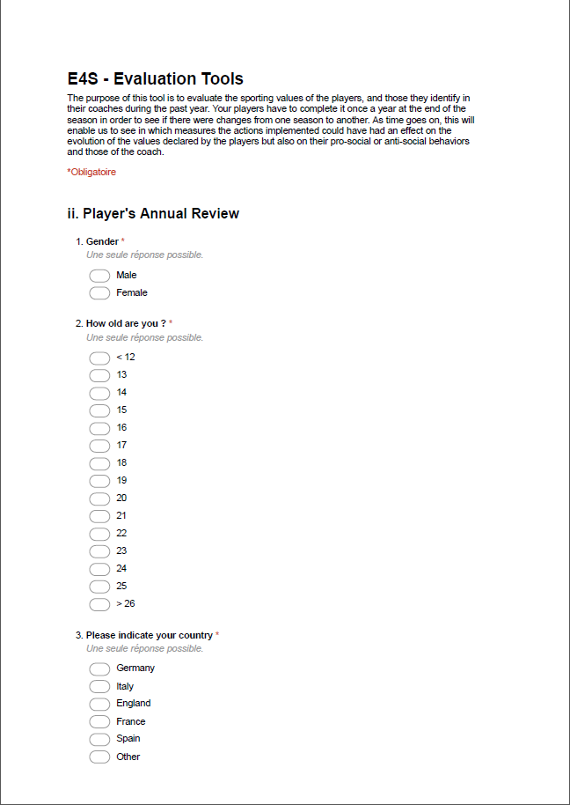

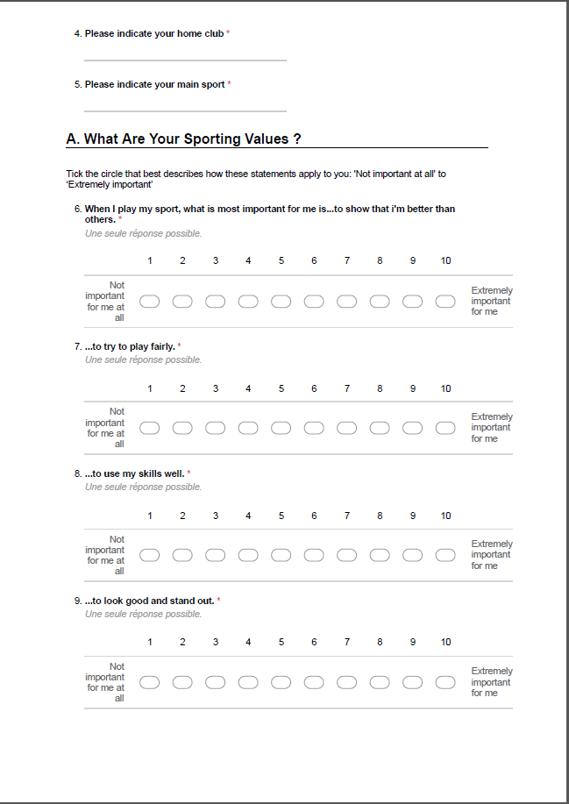

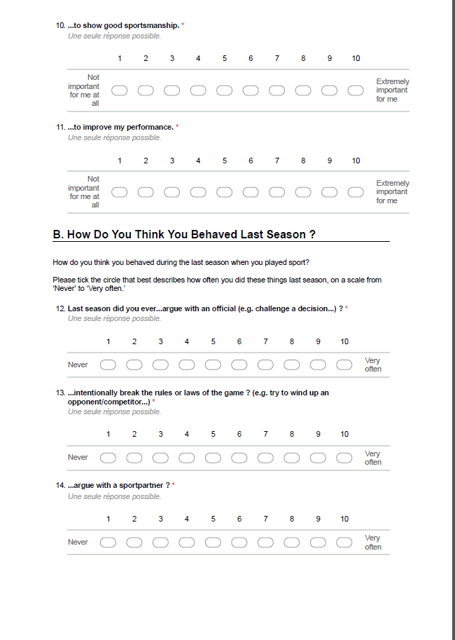

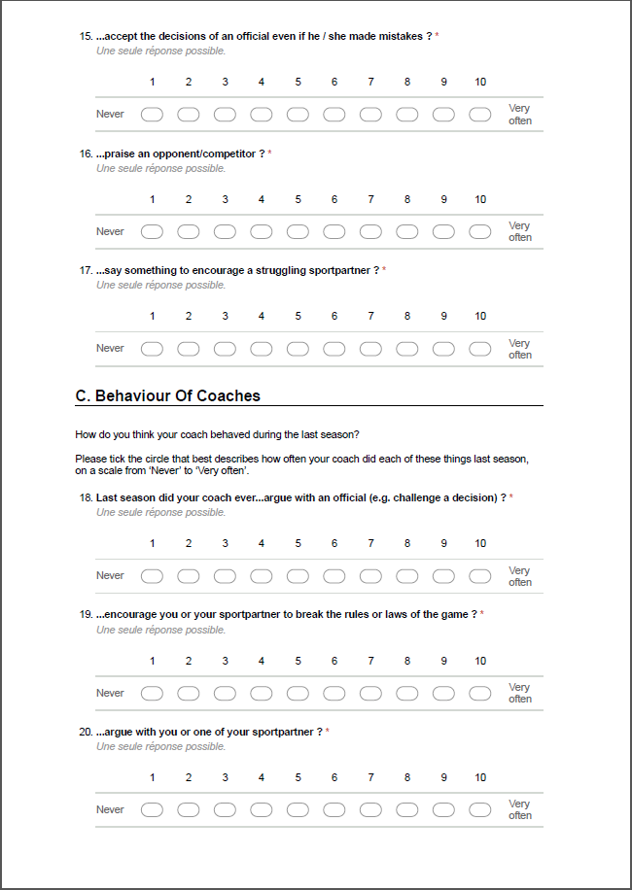

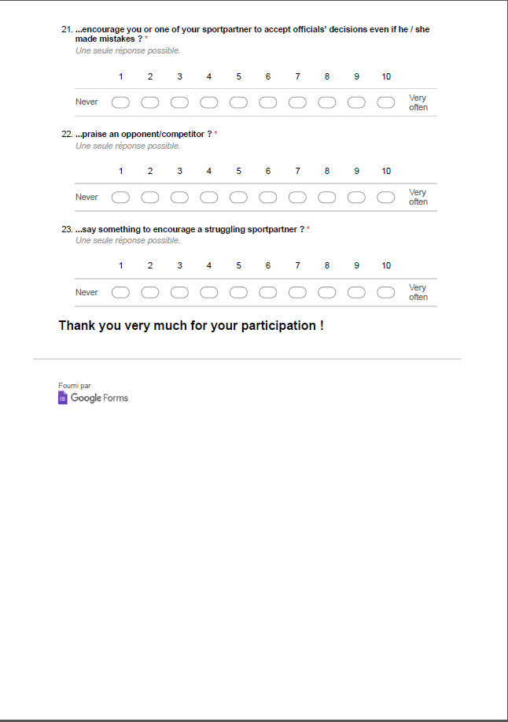

### ANNEX 4

### Google Form: Tool 1, Part 1

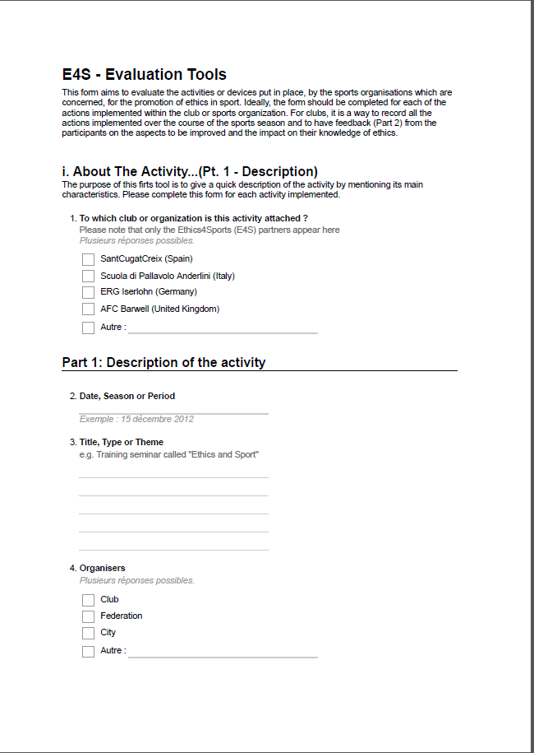

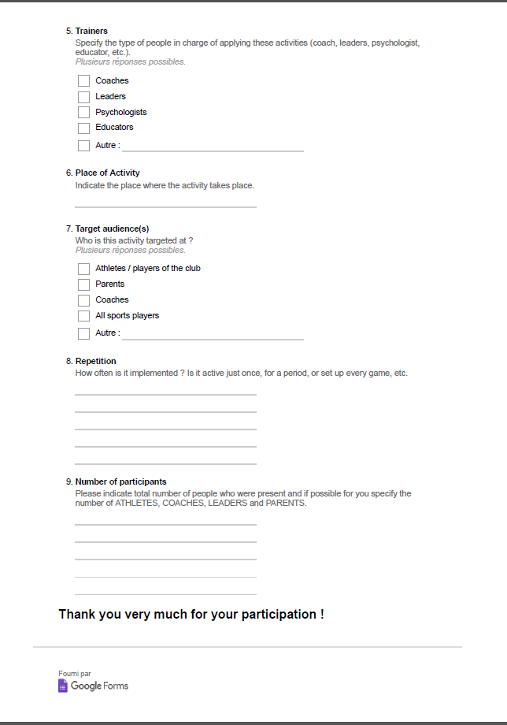

### ANNEX 5

### Google Form: Tool 1, Part 2

### 

### 

### ANNEX 6

### Google Form: Tool 3

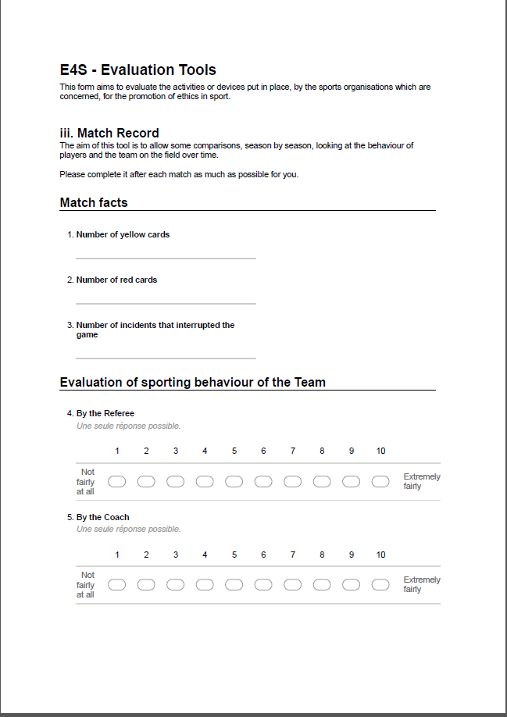

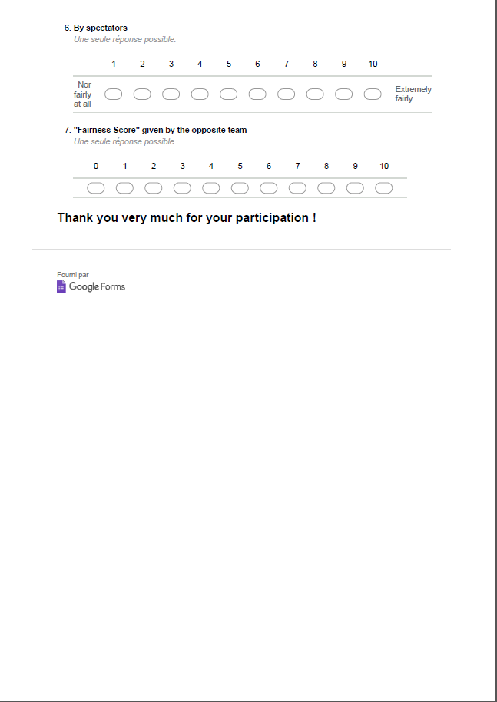

### ANNEX 7

### Excel Files to Produce Scores & Graphs for Different Data from Google Forms









1. M. J. Lee, J. Whitehead, N. Ntoumanis, & A. Hatzigeorgiadis (2008). Relationships among values, achievement orientations, and attitudes in youth sport. *Journal of Sport and Exercise Psychology*, 30, 588-610.
2. M. Kavussanu & I.D. Boardley (2009). ‘The pro-sosocial and antisocial -behaviour in sport scale.’ *Journal of Sport and Exercise Psychology*, 31 : 97-117.